**Assignment -3**

Cloud object storage and Watson assistant

|  |  |
| --- | --- |
| Assignment Date | 16 October 2022 |
| Student Name | M. Mahalakshmi |
| Student Roll Number | 951319104029 |
| Maximum Marks | 2 Marks |

**Question-1:**

Create a Bucket in IBM object storage

**Solution:**

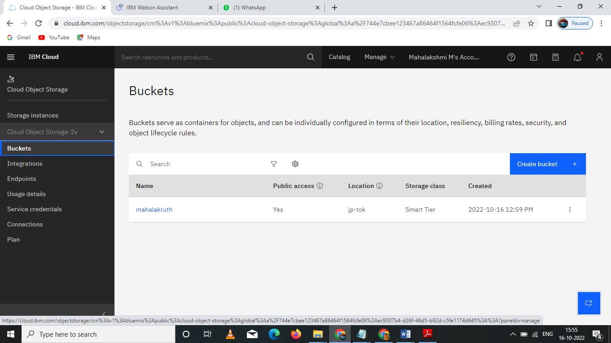

**Question-2:**

**Upload an 5 images to ibm object storage and make it public. Write html code to displaying all the 5 images.**

**Solution:**

**Html code:**

**<!DOCTYPE html>**

**<html>**

**<head>**

**<link rel="stylesheet" href="https://cloud-object-storage-er-cos-standard-1xw.s3.jp-tok.cloud-object-storage.appdomain.cloud/new.css">**

**</head>**

**<script>**

**window.watsonAssistantChatOptions = {**

**integrationID: "0b305951-d464-4f72-9cc7-938932287427", // The ID of this integration.**

**region: "jp-tok", // The region your integration is hosted in.**

**serviceInstanceID: "0e2633ff-6a5b-4e73-aca2-b88363b1cb5f", // The ID of your service instance.**

**onLoad: function(instance) { instance.render(); }**

**};**

**setTimeout(function(){**

**const t=document.createElement('script');**

**t.src="https://web-chat.global.assistant.watson.appdomain.cloud/versions/" + (window.watsonAssistantChatOptions.clientVersion || 'latest') + "/WatsonAssistantChatEntry.js";**

**document.head.appendChild(t);**

**});**

**</script>**

**<body>**

**<h1>This images are from the cloud object storage</h1>**

**<div class="grid-container">**

**<div class="item1"><img src="https://mahalakruth.s3.jp-tok.cloud-object-storage.appdomain.cloud/1_FHjF7YdCumva3EkMabyF0w.jpeg" alt="Girl in a jacket"></div>**

**<div class="item2"><img src="https://mahalakruth.s3.jp-tok.cloud-object-storage.appdomain.cloud/Female-Presenter.jpg" alt="Girl in a jacket"></div>**

**<div class="item3"><img src="https://mahalakruth.s3.jp-tok.cloud-object-storage.appdomain.cloud/IMG-20200715-WA0002.jpg" alt="Girl in a jacket"></div>**

**<div class="item4"><img src="https://mahalakruth.s3.jp-tok.cloud-object-storage.appdomain.cloud/digitalpen1.jpg"Girl in a jacket"></div>**

**<div class="item5"><img src="https://mahalakruth.s3.jp-tok.cloud-object-storage.appdomain.cloud/e-learning%20tile.jpg"Girl in a jacket"></div>**

**</div>**

**</body>**

**</html>**

**Output:**

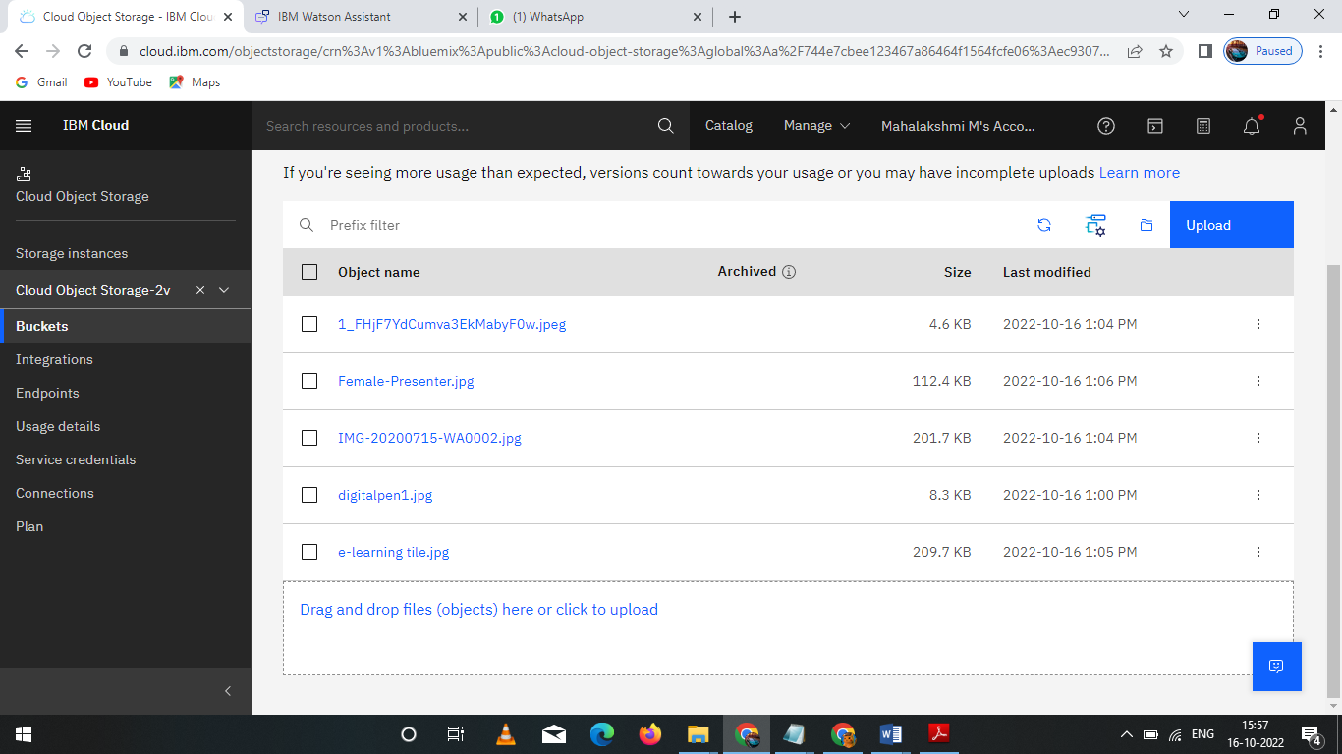

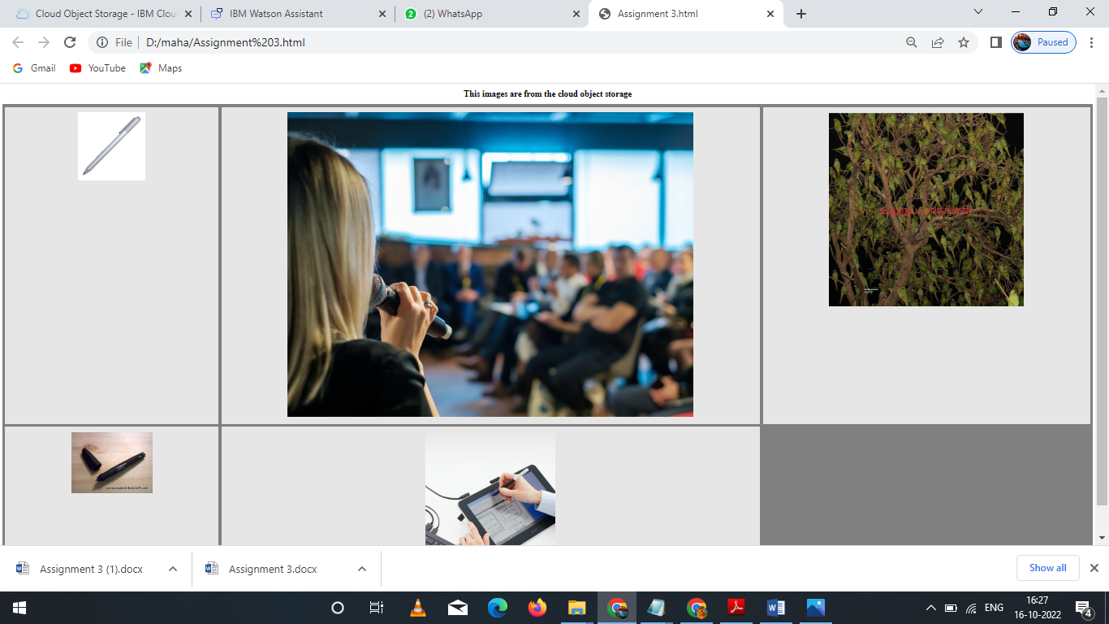

**Question-3:**

Upload a css page to the object storage and use the same page in your html code. Solution:

New.css uploaded to the object storage and used the same page in html code

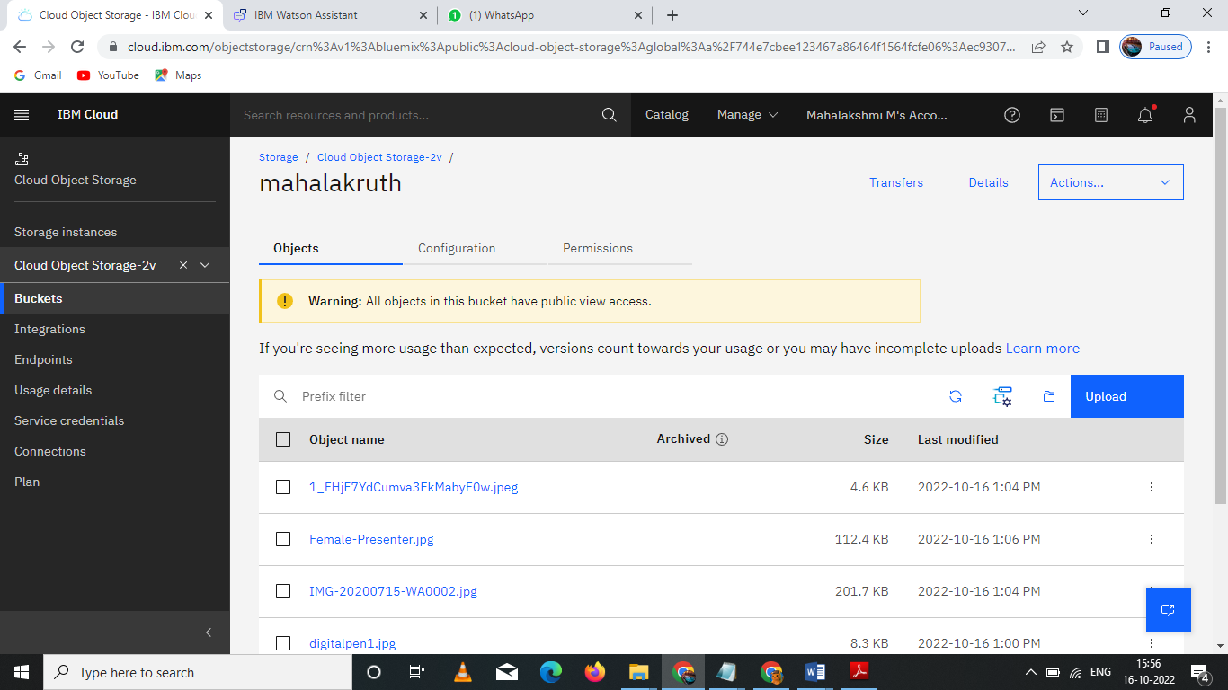

Css page used in html page



**Question-4:**

Design a Chabot using IBM Watson assistant for hospital. Ex: User come the query to know the braches for that hospital in your city.

Solution:

URL for: <https://web-chat.global.assistant.watson.appdomain.cloud/preview.html?backgroundImageURL=https%3A%2F%2Fau-syd.assistant.watson.cloud.ibm.com%2Fpublic%2Fimages%2Fupx-603018e1-4996-4dd4-86dc-95e357de29a9%3A%3A29317ed0-110b-4647-9ef9-8c35990db395&integrationID=78131e16-1956-4b2c-b782-e5d398675a0b&region=au-syd&serviceInstanceID=603018e1-4996-4dd4-86dc-95e357de29a9>

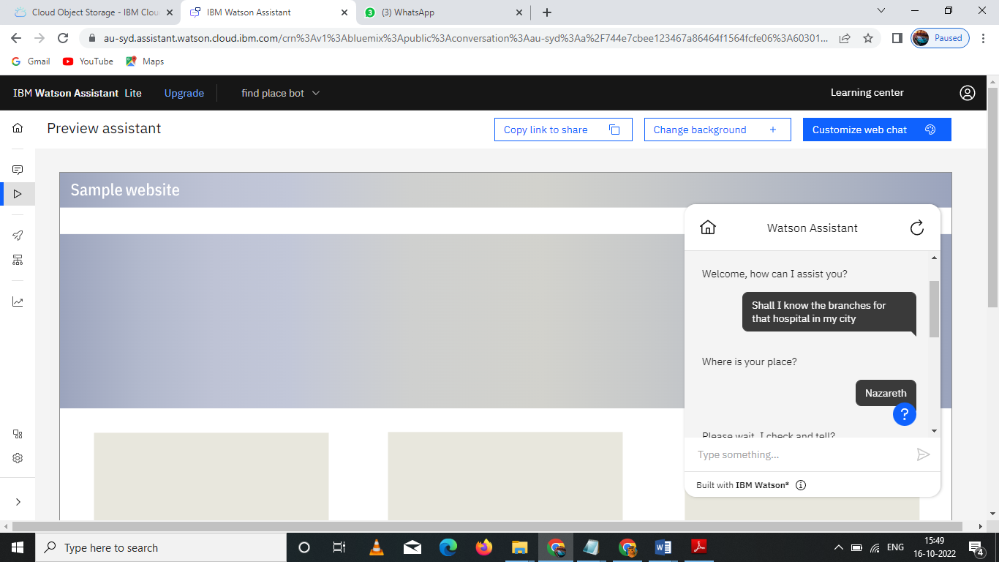

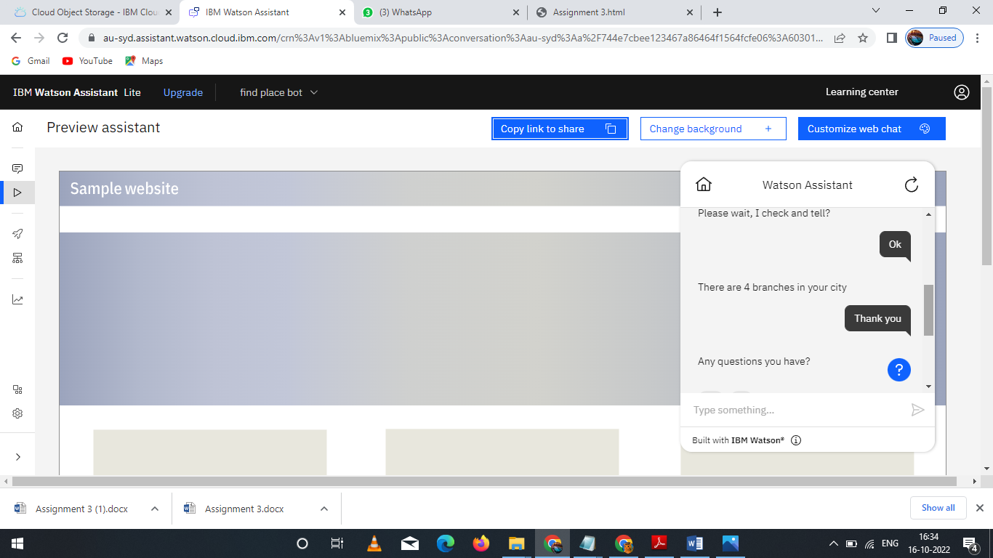

**Question-5:**

Create Watson assistant service with 10 steps and use 3 conditions in it. Load that script in html page Solution:

<!DOCTYPE html>

<html>

<head>

<link rel="stylesheet" href="https://cloud-object-storage-er-cos-standard-1xw.s3.jp-tok.cloud-object-storage.appdomain.cloud/new.css">

</head>

<script>

window.watsonAssistantChatOptions = {

integrationID: "0b305951-d464-4f72-9cc7-938932287427", // The ID of this integration.

region: "jp-tok", // The region your integration is hosted in.

serviceInstanceID: "0e2633ff-6a5b-4e73-aca2-b88363b1cb5f", // The ID of your service instance.

onLoad: function(instance) { instance.render(); }

};

setTimeout(function(){

const t=document.createElement('script');

t.src="https://web-chat.global.assistant.watson.appdomain.cloud/versions/" + (window.watsonAssistantChatOptions.clientVersion || 'latest') + "/WatsonAssistantChatEntry.js";

document.head.appendChild(t);

});

</script>

<body>

<h1>This images are from the cloud object storage</h1>

<div class="grid-container">

<div class="item1"><img src="https://mahalakruth.s3.jp-tok.cloud-object-storage.appdomain.cloud/1_FHjF7YdCumva3EkMabyF0w.jpeg" alt="Girl in a jacket"></div>

<div class="item2"><img src="https://mahalakruth.s3.jp-tok.cloud-object-storage.appdomain.cloud/Female-Presenter.jpg" alt="Girl in a jacket"></div>

<div class="item3"><img src="https://mahalakruth.s3.jp-tok.cloud-object-storage.appdomain.cloud/IMG-20200715-WA0002.jpg" alt="Girl in a jacket"></div>

<div class="item4"><img src="https://mahalakruth.s3.jp-tok.cloud-object-storage.appdomain.cloud/digitalpen1.jpg"Girl in a jacket"></div>

<div class="item5"><img src="https://mahalakruth.s3.jp-tok.cloud-object-storage.appdomain.cloud/e-learning%20tile.jpg"Girl in a jacket"></div>

</div>

</body>

</html>

Output:

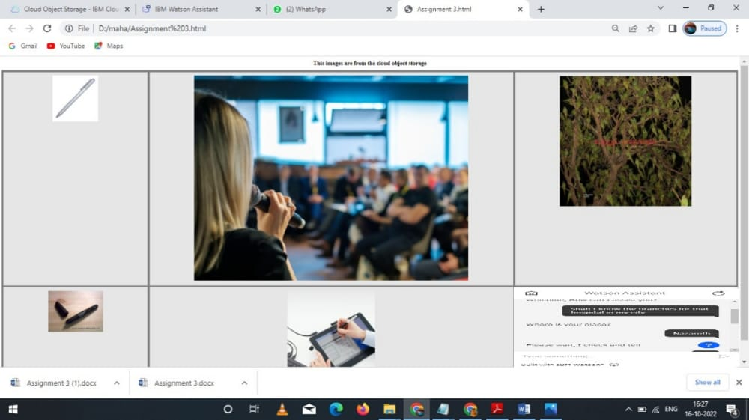

URL for chatbot : <https://web-chat.global.assistant.watson.appdomain.cloud/preview.html?backgroundImageURL=https%3A%2F%2Fau-syd.assistant.watson.cloud.ibm.com%2Fpublic%2Fimages%2Fupx-603018e1-4996-4dd4-86dc-95e357de29a9%3A%3A29317ed0-110b-4647-9ef9-8c35990db395&integrationID=78131e16-1956-4b2c-b782-e5d398675a0b&>region=au-syd&serviceInstanceID=603018e1-4996-4dd4-86dc-95e357de29a9

URL for webpage: <https://api.au-syd.assistant.watson.cloud.ibm.com/instances/603018e1-4996-4dd4-86dc-95e357de29a9>